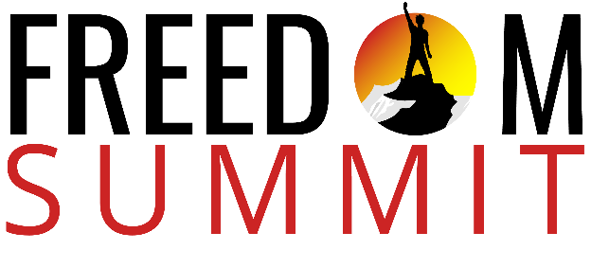
15-Step Quick Start Guide
Leading your won Freedom Summit

STEP #1. RECRUITYOUR LEADERSHIP TEAM
For best results, you’ll need a team to effectively minister freedom to men.
STEP #2. LEADERSHIP VISION CAST
Read and become conversant in the vision cast material provided. Once you get the freedom strategy clear in your mind and down in your spirit, then tap into your team’s creativity, energy, and anointing to customize it to best suit your needs.
The outline, strategy, and resources we provide, however, have been field tested and have provided remarkable results in the lives of hundreds of men’s lives over a long period of time.
STEP #3. DETERMINE RETREAT FORMAT
The Freedom summit can be effectively conducted in a variety of delivery options.
A. 3-Day Format. We have found that a Summit at an offsite venue such as a campground, high ropes course, cabins, etc. is ideal and serves to optimize the transformation. Men are out of their routine and this is to their advantage.
Having said that, you can also conduct 3-Day retreat on a church campus or similar location allowing the men to sleep at home each night. This saves money and offers other benefits.
B. 2-Day Format. This can be done offsite with one overnight stay. We have done that quite successfully but had to reduce the amount of recreation times to get the sessions in. The Freedom Summit differs from a typical “Men’s Retreat” because of its focus and objectives. The focus is on freedom and objective is life transformation by the power of God. Plenty of breaks and light recreation options are possible.
C. Virtual Format. The Freedom Summit can be done online using Zoom, etc.
D. Small Group Format. It cn be spread out over a quarter.
More details are available with suggested times in the Agenda section of the Dashboard.
STEP #4. ASSIGN ROLES & RESPONSIBILITIES

STEP #5. RESERVE VENUE & TECHNOLOGY

STEP #6. DETERMINE PROMOTION STRATEGY

STEP #7. SELECTRESOURCS FROM THE ONLINE DAASHBOARD FOR USE

STEP #8. DISTRIBUTE RESOURCES TO MATCH ROLE & RESPONSIBILITY ASSIGNMENTS

STEP #9. IMPLEMENT PROMOTION STRATEGY ROLLOUT

STEP #10. LEADERSHIP TEAM FINAL PLANNING

STEP #11. CAST VISOIN TO PROSPECTIBVE ATTENDEES

A. COLLECT REGISTRATOIN FEE

STEP #12. CONDUCT TTHE FREEDOM SUMMIT

STEP #13. REVIEW FEEDNBCAK FROM PARTICIPANTS

STEP #14. FINAL DEBRIEF WITH LEADERSHIPO TEAM

STEP #15. PLAN NEXT FREEDOM SUMMIT

